**Laboratory 2:**

DC and AC Circuits

**Name:** Omar Ozgur

**Date:** Jan 21, 2016 and Jan 28, 2016

**Lab:** Section 7, Thursday 8:00am

**TA:** Nicholas Rombes

**Lab Partner:** Uday Alla

**1. Introduction**

The purpose of this experiment was to explore various properties of direct current (DC) and alternating current (AC) circuits. In the first part of the experiment, a function generator was used to supply a direct current through circuits consisting of resistors and diodes. Recorded data was used to determine whether or not a resistor and a diode followed Ohm’s law. Circuits were also created to examine the properties of resistors in series and in parallel, as well as to determine the resistivity of a copper wire.

In the second part of the experiment, voltages through RC and LC circuits were recorded in order to analyze the transient states. Afterwards, the performance of an LRC circuit was used to determine the resonance frequency and quality factor of the system. Analysis of the data allowed for experimental results to be compared with theoretical properties of AC and DC circuits.

**2. Experimental Results**

**2.1 DC Circuits**

2.1.1 Verification of Ohm’s Law

In the first part of the experiment, the goal was to gather data to plot an IV relationship in order to verify that Ohm’s Law applies to a resistor *R*. In order to gather data regarding current and voltage, a resistor *r* with known resistance was connected in series with *R*, as shown in figure 1. In order to use a range of voltages, a function generator was used to apply voltages to the circuit in a triangular wave pattern at a frequency of 10 Hz. Various wires were used to measure the voltage drop across resistor *R* through channel 0 of an Analog to Digital converter (ADC), and to measure the voltage drop across resistor *r* through channel 1. By dividing the voltage across resistor *r* by its resistance, the current could be determined.

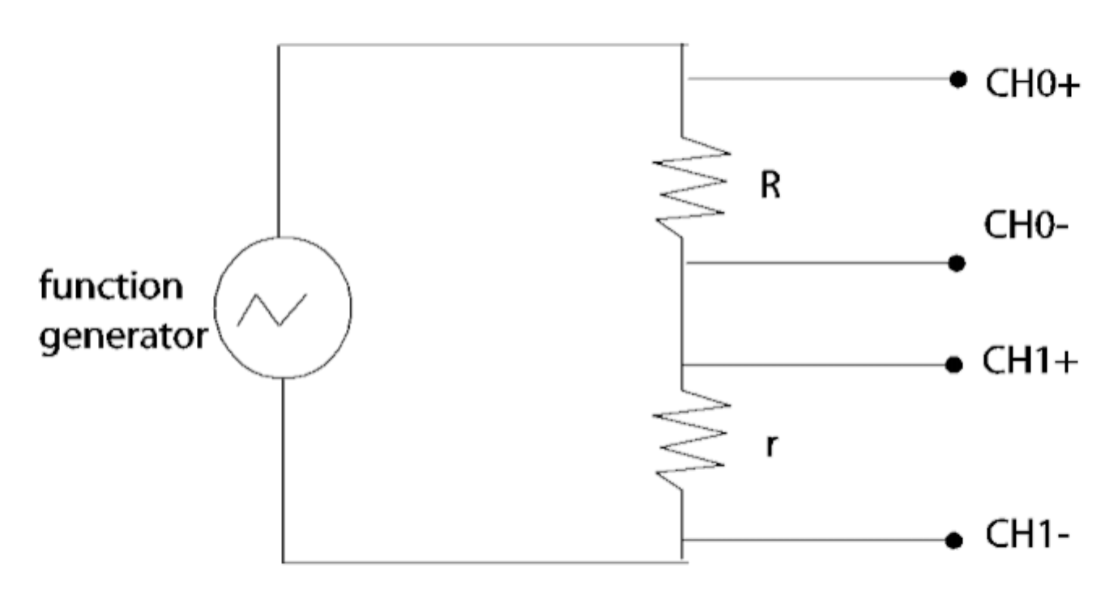

Figure : Circuit to Measure Voltages Across Resistors *R* and *r*: This image shows the circuit that was built in order to measure the IV curve of resistor *R*. The current could be determined by dividing measured voltage readings by the resistance of *r*. (Source: UCLA Physics 4BL Lab Manual, 2016)

Based on readings from a multimeter, the resistance of *R* was found to be 993.0 ± 0.5 Ω, and the resistance of *r* was found to be 100.0 ± 0.05 Ω. In order to generate an IV curve for resistor R, the provided “4BL” software was used to record voltage readings through channels 0 and 1 of the ADC at a sampling rate of 5,000 samples/sec for a sample size of 1,000 points. By dividing the voltage drop across resistor *r* by *r*’s known resistance, the current could be calculated. Based on the known current measurements and voltage readings across resistor *R*, an IV curve for resistor *R* was generated, which is shown in figure 2.

Figure : IV Curve for Resistor R: The points on this graph visually display the linear relationship between voltage and current for “unknown” resistor *R*. A regression tool in Microsoft Excel was used to find that the slope of the trend line was 1.005 ± 0.003 mΩ-1. This linear functional form helps to verify that Ohm’s law does apply to a resistor.

2.1.2 Resistors in Series and Parallel

In the second part of the experiment, two resistors *r* and *R* with similar resistance values were picked from the lab station. By using the multimeter, *r* was found to have a resistance of 3.30 ± 0.05 Ω, and *R* had a resistance of 7.50 ± 0.05 Ω.

After measuring the individual resistance values, wires were used to connect the resistors in series and in parallel. By using the multimeter again, the resistance of the resistors in series was found to be 11.10 ± 0.05 Ω, and the resistance in parallel was 2.30 ± 0.05 Ω.

2.1.3 Deviation from Ohm’s Law

In the next part of the experiment, the goal was to build a circuit that would allow for the creation of an IV curve for a diode. A resistor *r* with a known resistance of 100.0 ± 0.05 Ω was connected in series with the diode in order to calculate current based on voltage drop. The potential difference across the diode was recorded through channel 0 of the ADC, and the potential difference across resistor r was recorded through channel 1. A function generator was used to provide voltage at a frequency of 10 Hz in a triangular wave pattern. The configuration of the circuit is shown in figure 3.

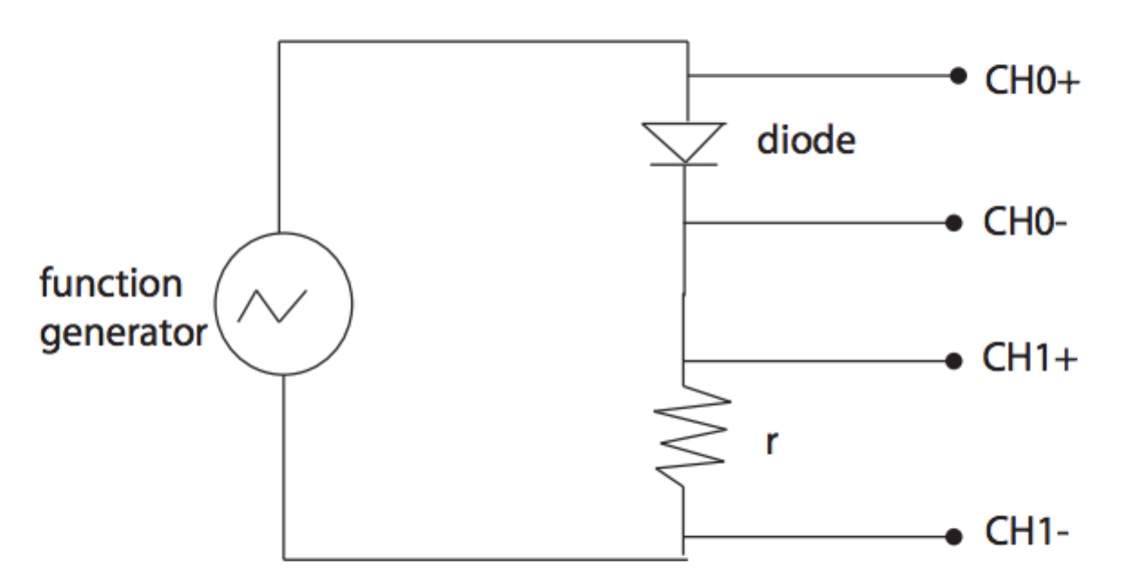

Figure : Circuit to Measure Voltages Across a Diode and Resistor *r*: This image shows the circuit that was built in order to measure the IV curve of a diode. The current could be determined by dividing measured voltage readings by the resistance of *r*. (Source: UCLA Physics 4BL Lab Manual, 2016)

In order to gather data, the provided “4BL” software was used to record voltage measurements from channel 0 and 1 of the ADC. The data was recorded at a sampling rate of 5,000 points/sec, for an ensemble size of 1,000 points. The voltage drop across the resistor was divided by the resistance of *r* in order to calculate current. The calculated current, along with the voltage measurements across the diode, were plotted in figure 4. A portion of the linearized data is displayed in figure 5.

Figure : IV Curve for a Diode: The data points in this graph visually show a non-linear relationship between voltage and current for a diode. As voltage increases around 0 V, the current increases exponentially, which shows a clear deviation from Ohm’s Law.

Figure : Linearized IV Curve for a Diode: In order to linearize the data shown in figure 4, the natural log of the current against the voltage across the diode. Much of the data had to be removed for small and negative voltage values, but the data points that are displayed show a clear linear trend. By using a regression tool in Microsoft Excel, the slope of the trend line was found to be13.21 ± 0.08 C/J.

2.1.4 The Conductivity of Copper

In order to calculate the resistivity of a given coil of copper wire, it was necessary to gather information regarding the coil’s resistance *R*, length *l*, and cross sectional area *A*. Since the wire gauge was #24 AWG (American Wire Gauge), it was known that the diameter was 0.021”. This information could be used to calculate *A*. It was also known that the mass density *ρm* was 8.920 g/cm3. By employing the use of a gram scale, the weight of the coil was found to be 253.0 ± 0.9 g. The known diameter, mass density, and weight could be used to calculate the length *l* of the wire.

In order to calculate the resistivity of the wire at two temperatures, the resistance *R* of the wire was measured at two temperatures with the multimeter. For the first measurement, the resistance at room temperature was found to be 10.20 ± 0.05 Ω. For the second measurement, the coil was immersed in liquid nitrogen, and the resistance of the wire was monitored until it reached a stable value of 1.40 ± 0.05 Ω. By using these resistance values along with the calculated length and cross sectional area values of the copper wire, the resistivity could be found at both temperatures.

**2.2 AC Circuits**

2.2.1 Transient State Measurements

The goal of the next part of the experiment was to analyze the transient state of a capacitor in an RC circuit. In order to do so, a resistor *R* with a resistance of 993.0 ± 0.5 Ω was connected in series with a capacitor *C* that had a capacitance of 1 μF so that the time constant τ would be approximately 10-3 s. A function generator was used to apply 2 volts to the circuit at a frequency of 120 Hz. The circuit layout is shown in figure 6.

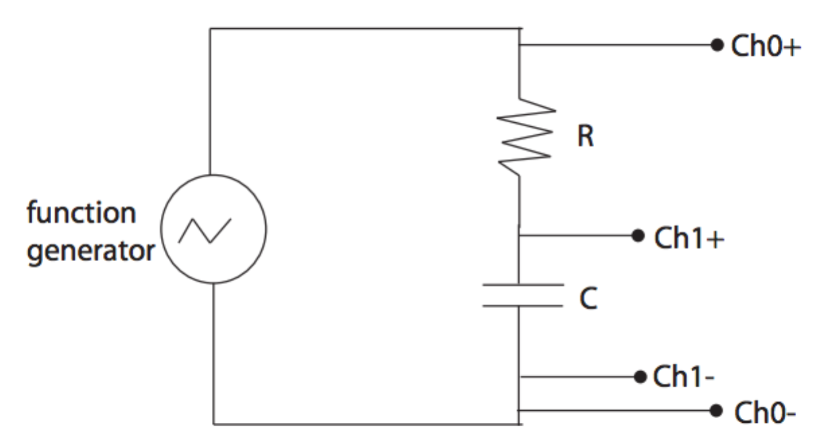

Figure : RC Circuit Setup: This image shows the layout for the circuit in this section of the experiment. The voltage data was recorded through the use of an ADC, and the results were plotted on a graph to display the RC transient period. (Source: UCLA Physics 4BL Lab Manual, 2016)

The voltage across the capacitor was recorded through channel 1 of the ADC, and voltage across the RC circuit was recorded through channel 0. By using the provided “4BL” software, a single ensemble of data was recorded at a sample rate of 2,500 points/sec for a sample size of 150 points. The recorded data is shown in figure 7. A portion of the linearized data for the RC transient is shown in figure 8.

Figure : RC Transient: This graph displays the recorded voltage data across the capacitor, as well as across the full RC circuit. The functional form by which the capacitor voltage increases or decreases to when an external voltage is applied or removed is exponential.

Figure : Linearized RC Graph: This graph displays the linearized data for one transient period from the RC circuit. A linear relationship between the linearized voltage and time can be seen. By using a regression analysis tool in Microsoft Excel, the slope of the linear trend line was found to be -1050 ± 10 s-1. The inverse of this value yields the measured time constant τ, which can be compared to the theoretical value.

The same experiment was repeated by replacing the capacitor from figure 6 with an inductor that had an inductance value of 0.001 H. In order to reduce the input impedance from the function generator, another resistor with a resistance of 3.40 ± 0.05 Ω was added to the circuit in parallel. The full circuit layout is shown in figure 9.

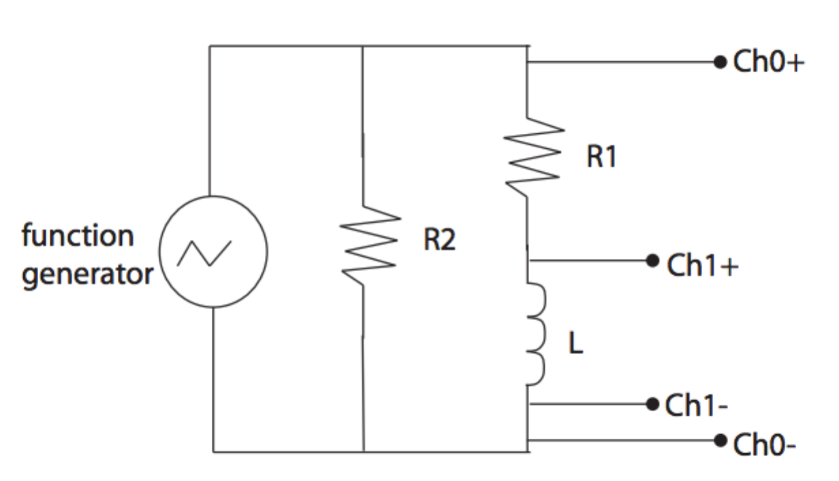

Figure : RL Circuit Setup: This image displays the RL circuit that was used in this section of the experiment. The voltage data was recorded through the use of an ADC, and the data was displayed on a graph to show the LC transient. (Source: UCLA Physics 4BL Lab Manual, 2016)

In order to measure the desired data, the provided “4BL” software was used to record the voltage across the inductor through channel 1 of the ADC, as well as the voltage across the RL circuit through channel 0. This data is displayed in figure 10.

Figure : LC Transient: This graph displays the recorded voltage data across the inductor and the full RL circuit. When the main voltage is applied or removed, the voltage across the inductor quickly jumps, and then exponentially returns to a stable state. During the experiment, there was an a problem that caused the square voltage pattern across the circuit to not be recorded accurately, as seen in the blue data points. This may have been fixed by altering the resistance of the resistor that was used in parallel with the circuit, or by altering settings on the function generator.

2.2.2 Resonance

In order to analyze the performance of an LRC circuit for a range of frequencies, a circuit was built with the layout displayed in figure 11. In this circuit, a 1 μF capacitor was used, along with a 993.0 ± 0.5 Ω resistor and a 1 mH inductor. The voltage across the circuit was recorded through channel 0 of the ADC, and the voltage across the resistor was recorded through channel 1. By using the provided “BODE Analyzer” software, an AC current was sent through the circuit, and the voltage response of the system was recorded as a function of frequency. This data is displayed in figure 12, and can be used to find the resonant frequency of the system.

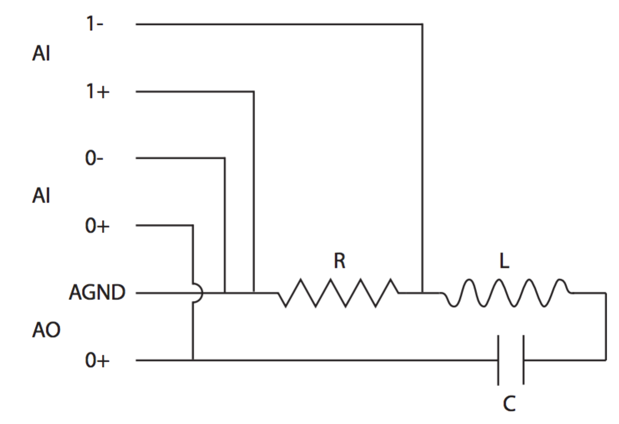

Figure : RLC Circuit Setup: This image shows the RLC circuit layout that was used in this portion of the experiment. While passing an AC current through the system, the voltage gain was found as a function of frequency. (Source: UCLA Physics 4BL Lab Manual, 2016)

Figure : RLC Circuit Resonance: This graph displays the recorded data from the RLC data that relates voltage gain to frequency. The parabolic functional form shows that the voltage gain increases until a particular frequency is used, after which the voltage gain decreases once again. The frequency that caused the greatest voltage gain is known as the fundamental frequency, and was found to be 1651.700 ± 0.005 Hz. The horizontal line represents the value $Gain_{max}/\sqrt{2}$, which can be used to calculate the quality factor.

**3. Analysis**

3.1 Ohm’s Law

Based on the measured data shown in figure 2, it is possible to calculate the “unknown” resistance of resistor *R*. By performing linear regression analysis on the measured voltage and current values, the slope of the least squares fit line can be found. Since this slope represents the relationship between current and voltage, equation 1 can be used to show that the inverse of the slope is the theoretical resistance value of *R*.

$I=\frac{V}{R}$ (1)

In order to calculate the values for current that are shown in figure 2, the measured voltage and resistance values of “known” resistor *r* were used in equation 1. This allowed for the current to be calculated for every measured voltage value.

In order to perform the specified regression analysis, I used a regression tool that can be found in the Microsoft Excel “Analysis ToolPak”. By using the tool on the measured current and voltage values for resistor R, I found that the slope *m* of the least squares fit was 1.005 ± 0.003 mΩ-1. In order to use this information to calculate the theoretical resistance value for R, along with its uncertainty, I used the equations below.

$R=\frac{1}{m}$ (2)

$σ_{F}=\sqrt{{\left(\frac{∂f}{∂x}\right)}^{2}{\left(σ_{x}\right)}^{2}+{\left(\frac{∂f}{∂y}\right)}^{2}{\left(σ_{y}\right)}^{2}}$ (3)

$σ_{R}=\sqrt{{\left(\frac{∂R}{∂m}\right)}^{2}{\left(σm\right)}^{2}}$ (4)

$\frac{∂R}{∂m}=-\frac{1}{m^{2}}$ (5)

Based on equations 2 and 4, I found that the theoretical resistance of resistor *R* was

999 ± 3 Ω. Although this does not agree with the measured value of 993.0 ± 0.5 Ω based on the given error bounds, the slight deviation of roughly 0.3% may be attributed to sources of uncertainty, such as added resistance from connected components of the circuit.

3.2 Resistors in Series and in Parallel

Experimental data showed that for two resistors of resistances 3.3 ± 0.5 Ω and 7.5 ± 0.5 Ω, the measured resistance of the resistors in series was 11.1 ± 0.5 Ω, and the resistance when they were in parallel was 2.3 ± 0.5 Ω. The theoretical resistance values of *n* resistors in series could be calculated through the use of equations 6 and 7.

$R_{series}=R_{1}+R_{2}+…+R_{n}$ (6)

$\frac{1}{R_{parallel}}=\frac{1}{R_{1}}+\frac{1}{R_{2}}+…+\frac{1}{R_{n}}$ (7)

Based on these equations, the theoretical resistance value of the resistors in series is 10.8 ± 0.7 Ω, and in parallel is 2.29 ± 0.5 Ω. These uncertainty values were calculated through the use of equation 3. By comparing these values to the experimental resistance values, it can be seen that the values agree with each other based on the given error bounds, which helps to verify the accuracy of the experimental procedures.

3.3 Deviation from Ohm’s Law

In order to calculate the values for current that are shown in figure 4, the recorded voltage readings from the “known” resistor were divided by the its resistance of 100.0 ± 0.5 Ω through equation 1. Before linearizing the data, the constant *I0* for the diode was found to be -1.35 •10-5 ± 8 •10-8 A. The uncertainty in this measurement was found by using equations 3 and 8, where *Vr* and *r* represent the voltage and resistance of the resistor in series.

$σ_{I_{0}}=\sqrt{{\left(\frac{∂I_{0}}{∂V_{r}}\right)}^{2}{\left(σ_{V_{r}}\right)}^{2}+{\left(\frac{∂f}{∂r}\right)}^{2}{\left(σ_{r}\right)}^{2}}$ (8)

Since the calculated value *I0* was much smaller than the rest of the current values, calculation *I + I0* was approximated simply as *I*. The original IV relationship shown in figure 4 was based on equation 9.

$I+I_{0}=I_{0}(e^{\left|e\right|V/nk_{B}T})$ (9)

In order to linearize the data, the natural logarithm of the calculated current values was graphed against the potential difference across the diode, based on equation 10.

$\ln\left(I\right)=\ln\left(I_{0}\right)+\left(\frac{e}{nk_{B}T}\right)V$ (10)

This resulted in poor results for negative or small voltage values. A portion of the data that showed a clean linear relationship is displayed in figure 5. By using a regression analysis tool in Microsoft Excel, the slope of the graph was found to be 13.21 ± 0.08 C/J. This represents the measured relationship $\frac{e}{nk_{B}T}$ shown in equation 10. By taking the diode’s constant *n* value to be 2, and the temperature *T* to be 293 K, the experimental value of the ratio $\frac{e}{k_{B}}$ was found to be 7741 ± 7 $\frac{CK}{J}$. The uncertainty in this value was calculated through the use of equation 3.

The theoretical vale of $\frac{e}{k_{B}}$ based on accepted values for e = 1.6 • 10-19 C and *kB* = 1.38 • 10-23 was found to be 11594 $\frac{CK}{J}$, with negligible uncertainty. By comparing the experimental and theoretical values for the specified ratio, it can be seen that the values do not agree with each other based on the given error bounds. The percentage error is roughly 50%. One large source of error was likely the fact that most of the data had to be discarded during linearization in order to obtain a clean linear trend. By repeating this experiment with different frequencies and resistances, the calculated data may have come closer to theoretical values.

3.4 The Conductivity of Copper

In one part of the lab, the goal was to calculate the resistivity of a copper wire at two different temperatures. The diameter *d* of the wire was known to be 0.021” with negligible uncertainty, and the mass density *ρm* was 8.92 g/cm3 with negligible uncertainty. During the experiment, a gram scale was used to find that the mass of the coil was 253 ± 0.9 g. Based on this information, the following equations were used to calculate the length of the wire:

$$ρ_{m}=\frac{8.92g}{cm^{3}}∙\frac{{100}^{3}cm^{3}}{m^{3}}∙\frac{1kg}{1000g}=\frac{8920kg}{m^{3}}$$

$$r=\frac{0.021"}{2}∙\frac{0.0254m}{1"}=2.667∙{10}^{-4}m$$

$$V=\frac{m}{ρ_{m}}=\frac{0.253kg}{8290\frac{kg}{m^{3}}}=2.84∙{10}^{-5}m^{3}$$

$σV=1∙{10}^{-7}m^{3}$ (Based on equation 3)

$$l=\frac{V}{πr^{2}}=\frac{2.84∙{10}^{-5}m^{3}}{π{\left(2.667∙{10}^{-4}\right)}^{2}}=127.1m$$

$σl=0.4m$ (Based on equation 3)

The previous information was used to find the resistivity of the wire at room temperature (T = 293K), as well as at the temperature of liquid nitrogen (T ≈ 75 K).

$ρ=\frac{RA}{l}$ (11)

Based on equation 11, the resistivity of the coil with a resistance of 10.2 ± 0.5 Ω at room temperature was found to be $1.79∙{10}^{-8}±9∙{10}^{-10} Ω∙m$. The resistivity of the coil with a resistance of 1.4 ± 0.5 Ω at the temperature of liquid nitrogen was found to be $2.46∙{10}^{-9}±9∙{10}^{-10} Ω∙m$. The uncertainty in these calculations were based on equation 3.

Based on the *Handbook of Chemistry and Physics*, the theoretical resistivity of copper is $1.7μΩ∙cm$. Compared to the experimental value that was attained at approximately the same temperature, the values do agree with each other based on the given error bounds. This helps to verify the accuracy of the experimental methods that were used to calculate resistivity.

3.5 Transient Measurements

In order to further analyze the data shown in figure 7, a few calculations were done to linearize the data. Based on the square voltage that was applied, the data shows that the voltage jumps from a value of approximately 0 V to a maximum value *VB* = 3.83 ± 5 • 10-6 V. The original equation for the voltage across the capacitor is given by equation 12.

$V_{C}\left(t\right)=V_{b}(1-e^{-\frac{t}{RC}})$ (12)

In order to linearize the data, the natural logarithm of the transient state data was taken, as shown in equation 13. The linearized data is displayed in figure 8.

$\ln\left(V_{b}-V\right)=\ln\left(V_{b}\right)-\frac{1}{RC}t$ (13)

By using a regression analysis tool in Microsoft Excel, the positive slope of the linear trend line displayed in the graph was found to be 1050 ± 10 s-1. Based on equation 13, the inverse of this slope value corresponds to the value τ = RC, which shows that the experimental value of τ is 9.52 • 10-4 ± 9 • 10-6 s. The uncertainty in this value is based on equation 3.

Based on the experimental resistance value of 993.0 ± 0.5 R, and the capacitance value of 1 μF, the theoretical value τ is 9.93 • 10-4 ± 5 • 10-7 s.

Although the experimental and theoretical values of τ do not agree with each other based on the given error bounds, the values are reasonably close, as the percentage error is roughly 4%. The small difference in error may be due to factors such as added internal resistance in the circuit.

3.6 Resonant Circuit

Based on the RLC circuit data shown in figure 12, the resonant frequency was found to be 1651.700 ± 0.005 Hz. The theoretical value of the resonant frequency could be calculated based on the experimental inductance of 10 mH and capacitance of 1 μF through the use of equation 14.

$f_{res}=\frac{1}{2π\sqrt{LC}}$ (14)

The results show that the theoretical resonant frequency was 1591.5 Hz, with negligible uncertainty. This value does not agree with the experimental resonant frequency, and the percentage error was about 4%. The discrepancy may have been due to additional resistance within the circuit.

In order to calculate the quality factor *Q* based on the frequency data, it was first necessary to find the maximum voltage gain, which was 1.815 ± 0.005 dB in this case. A line was then drawn at a height of $\frac{Gain_{max}}{\sqrt{2}}$ = 1.283 ± 0.004 dB to represent the height of the resonance peak. Based on this information, the quality factor could be calculated by using the values of the resonance frequency, along with the frequencies at the points that intersect the horizontal line (*f2* and *f1*), in equation 15.

$Q=\frac{f_{res}}{(f_{2}-f_{1})}$ (15)

The values *f2* and *f1* were found to be 6136.772 ± 0.005 Hz and 424.561 ± 0.005 Hz respectively. Therefore, the calculated quality factor in this experiment was 0.29 ± 9 • 10-7. The uncertainty in this value was based on equation 3.

**4. Conclusion**

The purpose of this lab was to explore many of the properties of DC and AC circuits. In the first section of the lab, a linear relationship between current and voltage was used to show that Ohm’s law applies to a resistor. However, when calculating the resistance of the “unknown” resistor, the value did not agree with the theoretical value. This sort of discrepancy between experimental and theoretical values was seen for most of the calculations in this lab. However, the calculated error percentages were typically small, which indicated that the errors were likely due to small factors such as internal resistance in the circuits that was unaccounted for.

In the next part of the lab, the resistance of resistors in parallel and in sequence was examined, which helped to verify theoretical calculations. Afterwards, an IV curve was created to show that Ohm’s law does not apply to a diode. The linearized data helped to determine the experimental value for the ratio e/kB. The next part of the experiment involved calculating the resistivity of a copper wire, which showed different resistivity values at different temperatures due to varying resistance.

In set of AC circuit experiments, an RC and RL circuit was created, and the data was graphed to show the transient states. In the analysis, the RC transient state was examined to determine the RC time constant τ, which was close to the theoretical value. An RLC circuit was then used to determine the resonance frequency of the system, as well as the quality factor *Q*.

Although some of the calculated experimental values did not agree with the theoretical results, the calculated error percentages were not very large. It is reasonable to consider that these differences were due to factors such as internal resistance of instruments, or the frequencies that were used. The results of the experiments successfully demonstrated the objectives of the lab by allowing for the exploration and validation of many properties of DC and AC circuits.